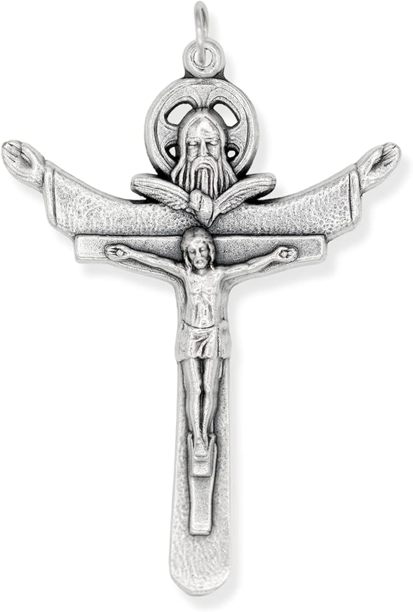
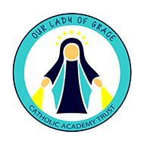

Sign of the Cross Prayer
In the name of the Father, and of the Son and of the Holy Spirit. Amen.


Morning Prayer- St Edward’s Prayer

Most glorious St. Edward, you showed your devotion to God with patience, gentleness and generosity. Like you, may I serve to strengthen the Kingdom of God through patient prayer and charity.

The Lord’s Prayer

Our Father who art in heaven, hallowed be thy name. Thy kingdom come. Thy will be done on earth, as it is in heaven. Give us this day our daily bread, and forgive us our trespasses, as we forgive those who trespass against us, and lead us not into temptation, but deliver us from evil.

The Hail Mary

Hail, Mary, full of grace, the Lord is with thee. Blessed art thou among women and blessed is the fruit of thy womb, Jesus. Holy Mary, Mother of God, pray for us sinners, now and at the hour of our death. Amen.

Glory be to the Father
Glory be to the Father and to the Son and to the Holy Spirit, as it was in the beginning is now, and ever shall be world without end. Amen
Grace Before Lunch

Bless us, O Lord, and these your gifts which we are about to receive from your bounty. Through Christ our Lord. Amen.

Grace After Lunch
We give you thanks, Almighty God, for all your benefits, who live and reign, world without end. Amen.

Home Time Prayer- Act of Contrition

O my God, because you are so good, I am very sorry that I have sinned against you, and with the help of your grace I will not sin again.
Amen.

