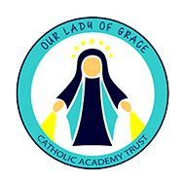

Sign of the Cross Prayer
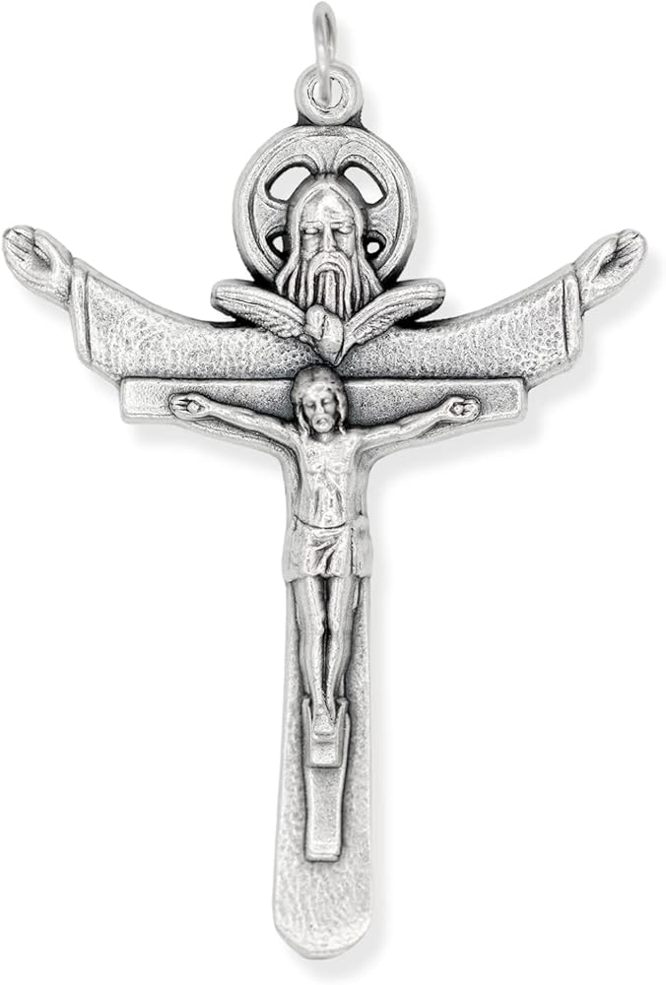
In the name of the Father, and of the Son and of the Holy Spirit. Amen.

Morning Prayer

O my God you love me,
You’re with me night and day.
I want to love you always,
In all I do and say. I try to please you.
Father, Bless me through the day. Amen.

Home Time Prayer
At the end of the day, we turn and say.
Thank you God for my work and play.
I try to be good, cos I know that I should

That’s my prayer at the end of the day. Amen.

Grace Before Lunch
Bless us Oh God, As we sit together,
Bless the food we eat today,
Bless the hands that make the food.
Bless us Oh Lord, Amen.
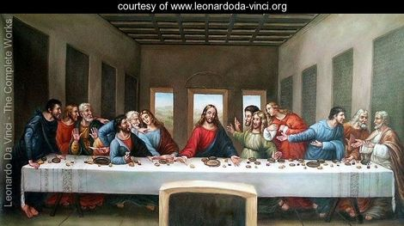

Grace After Lunch
Thank you God, for the world so sweet.
Thank you God, for the food we eat
Thank you God, for the birds that sing.

Thank you God for everything, Amen.

I Belong to You
From my head, to my heart, from my shoulder to my shoulder, I belong to you Lord Jesus, Amen.

