

Sign of the Cross Prayer
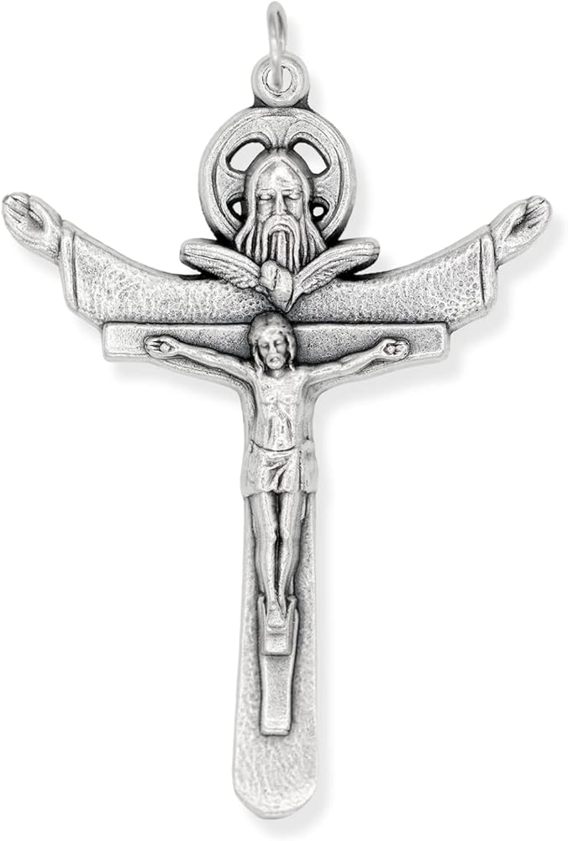
In the name of the Father, and of the Son and of
the Holy Spirit. Amen.


Morning Prayer- Angel of God

Angel of God, my guardian dear, to whom God’s love commits me here, ever this day be at my side, to light and guard, to rule and guide. Amen

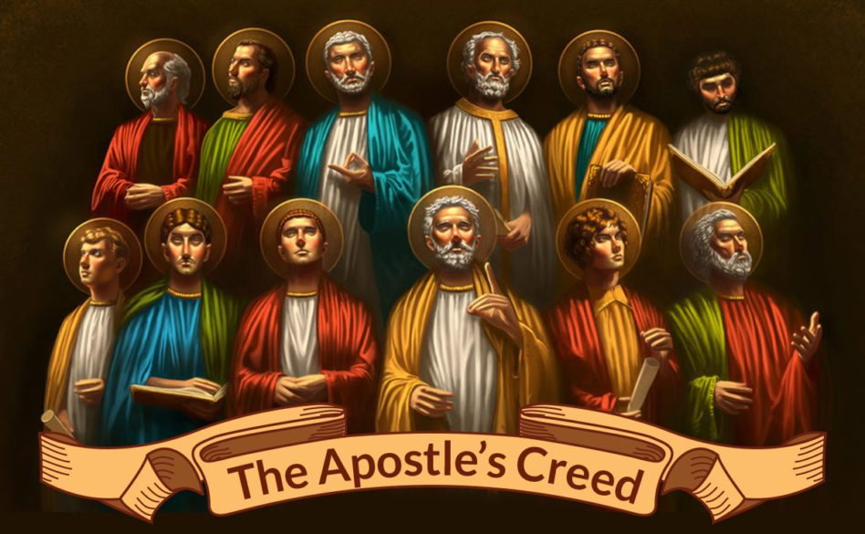
Apostles Creed
I believe in God, the Father Almighty Creator of heaven and earth, and in Jesus Christ, his only Son, our Lord, At the words that follow, up to and including the Virgin Mary, (all bow) who was conceived by the Holy Spirit, born of the Virgin Mary,
suffered under Pontius Pilate, was crucified, died and was buried; he descended into hell; on the third day he rose again from the dead; he ascended into heaven, and is seated at the right hand of God the Father almighty; from there he will come to judge the living and the dead.
I believe in the Holy Spirit, the holy catholic Church, the communion of saints, the forgiveness of sins, the resurrection of the body, and life everlasting. Amen.

Come, Holy Spirit

V. Come, Holy Spirit, fill the hearts of your faithful.
R. And kindle in them the fire of your love.
V. Send forth your Spirit and they shall be created.
R. And you will renew the face of the earth.
Let us pray-O God, who by the light of the Holy Spirit, did instruct the hearts of your faithful, grant that by that same Holy Spirit, we may be truly wise, and ever rejoice in your consolation, Through Christ our Lord. Amen.

Grace Before Lunch  Bless us, O Lord, and these your gifts which we are about to receive from your bounty. Through Christ our Lord. Amen. |   Home Time Prayers | Grace After Lunch  We give you thanks, Almighty God, for all your benefits, who live and reign, world without end. Amen.

Prayer of St Richard of Chichester
Thanks be to you, my Lord Jesus Christ, for all the benefits which you have given me, for all the pains and insults which you have borne for me. O most merciful Redeemer, friend and brother, may I know you more clearly, love you more dearly, and follow you more nearly, day by day. Amen.
Act of Contrition

O my God, because you are so good, I am very sorry that I have sinned against you, and with the help of your grace I will not sin again. Amen.

