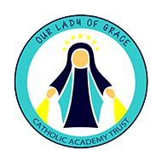

Sign of the Cross Prayer
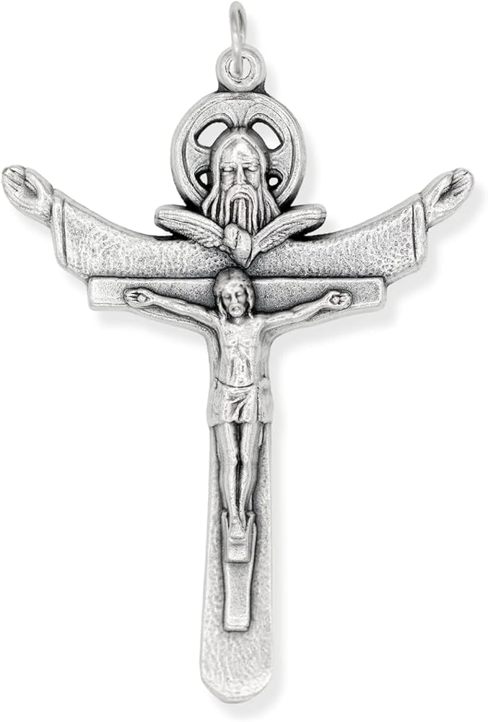
In the name of the Father, and of the Son and of
the Holy Spirit. Amen.


Morning Prayer Offering
O Jesus, through the most pure heart of Mary, I offer you all my prayers, thoughts, works and sufferings of this day for all the intentions of your most Sacred heart. Amen

The Magnificat
My soul proclaims the greatness of the Lord, and my spirit rejoices in God my Saviour, for he has looked upon his handmaid in her lowliness; for behold, from this day forward,
all generations will call me blessed. For the Almighty has done great things for me, and holy is his name.
His mercy is from age to age for those who fear him.
He has made known the strength of his arm,
and has scattered the proud in their conceit of heart.

He has cast down the mighty from their thrones and has exalted those who are lowly. He has filled the hungry with good things, and has sent the rich away empty. He has helped his servant Israel, mindful of his mercy, even as he promised to our fathers, to Abraham and his descendants for ever. Glory be to the Father and to the Son and to the Holy Spirit, as it was in the beginning, is now, and ever shall be, world without end. Amen.

Grace Before Lunch  Bless us, O Lord, and these your gifts which we are about to receive from your bounty. Through Christ our Lord. Amen. |  | Grace After Lunch  We give you thanks, Almighty God, for all your benefits, who live and reign, world without end. Amen.
Home Time Prayers

Act of Faith

My God, I believe in you and all that your Church teaches, because you have said it, and your word is true.

Act of Hope
My God, I hope in you, for grace and for glory,
because of your promises, your mercy and your power.

Act of Love


My God, because you are so good, I love you with all my heart, and for your sake, I love your neighbour as myself.

